

**Dorset Local Enterprise Partnership**

**REQUEST FOR QUOTATIONS**

**Growing Places Fund**

**Due Diligence**

**November 2023**

Contents

1. BACKGROUND 3

2. BUDGET AND DURATION 5

3. OBJECTIVE 5

4. OUTPUTS 7

5. CONTRACT MANAGEMENT AND MONITORING 7

6. TIMETABLE 7

7. REQUEST FOR QUOTATIONS ASSESSMENT AND COMMISSIONING PROCEDURE 8

8. REQUEST FOR QUOTATION GUIDANCE 9

# BACKGROUND

* 1. The Growing Places Fund (GPF) was allocated to Local Enterprise Partnerships across England for the establishment of a recoverable and recyclable fund to address constraints to economic growth in their area. In 2012, Dorset Local Enterprise Partnership (LEP) was allocated £9.7m for such a scheme.
  2. GPF is designed to unlock capital projects which have a significant economic impact and the potential to increase innovation & productivity, create jobs & housing and deliver tangible economic outcomes. The fund may also be used where businesses are unable to access alternative funding mechanisms for viable schemes that will deliver economic growth and support Dorset LEP’s strategic objectives.
  3. Dorset LEP manages the fund with support from Dorset Council, ensuring financial and legal requirements are met. The GPF repayment profile is defined in a contractual agreement between Dorset Council on behalf of the Dorset LEP and the applicant. Appropriate security will be required to release any approved loan. The features of the loan fund include a commercially attractive interest rate and negotiable terms for the start of the repayment schedule.
  4. To date, Dorset LEP has invested £17.3 million across 13 projects. In 2021/22, £4.8 million was invested in two projects. Funded projects vary significantly in terms of scale and sector, but all help to increase innovation and productivity and create jobs, infrastructure and housing that support the growth of the local economy. Details of previously successful projects can be found on the Dorset LEP website.
  5. The application and selection process for the Growing Places Fund is designed to be a simple and straightforward two-stage process, allowing the Dorset LEP to undertake robust appraisal and due diligence and thus to safeguard the LEP’s interests. Stage 1 is the initial application and stage 2 is the submission of detailed business information as part of the due diligence process. The stage 1 and stage 2 processes are outlined in the graphs below, and the draft Stage 1 application is attached to this Request for Quotations (RFQ):

**STAGE 1**

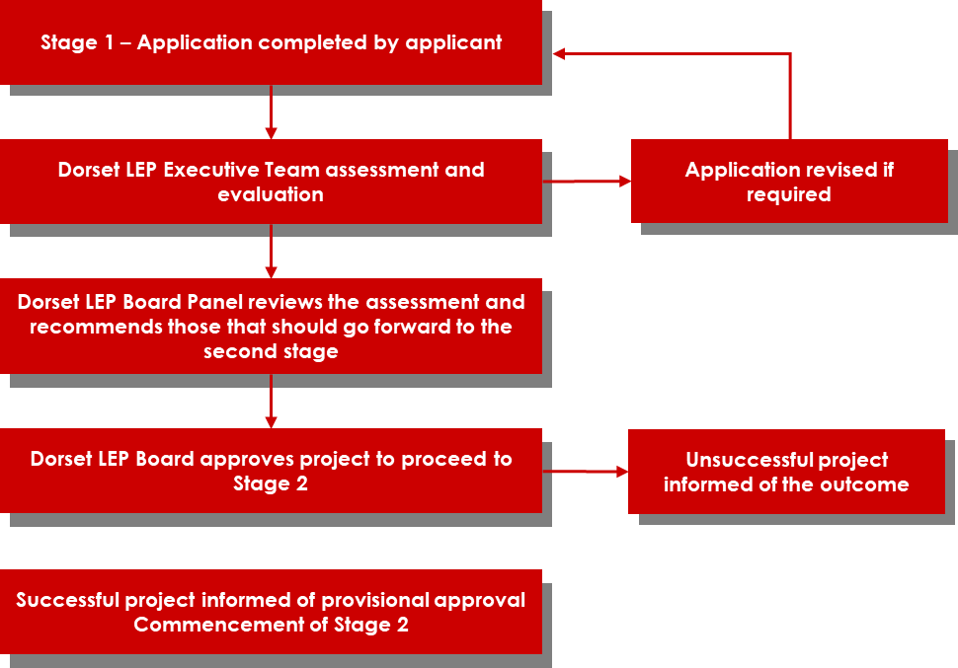

**STAGE 2**

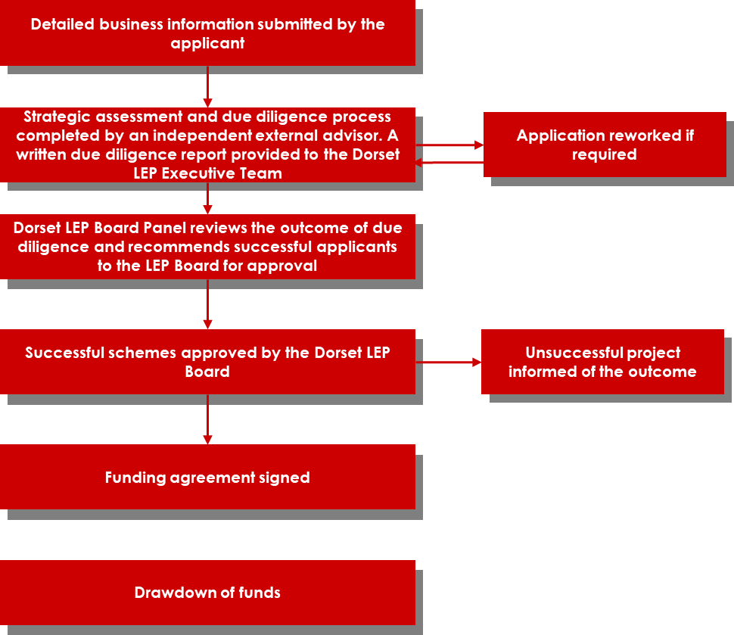

*Dorset LEP Board may delegate approval to the Dorset LEP Board Panel

* 1. The tentative timeline for stage 1 and stage 2 of the Growing Places Fund application process is outlined below.

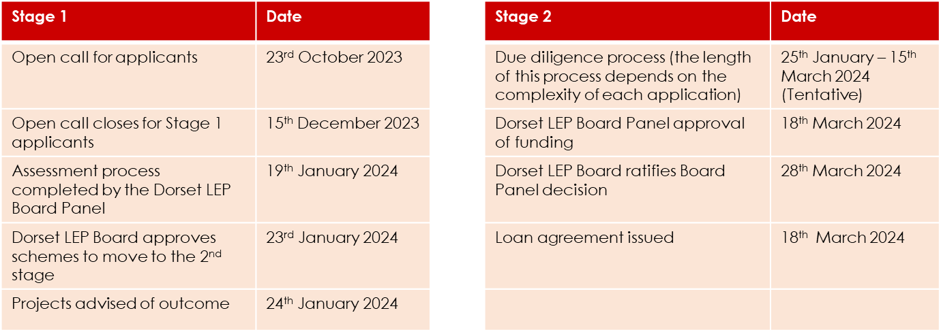

1. **BUDGET AND DURATION**

2.1 The contract is to run from 18th December 2023 to 30 June 2024.

2.2 The maximum budget allocated is £ £40,000 to support a maximum of 8 submitted business cases.

# OBJECTIVE

* 1. In order to comply with the requirements of the Dorset Local Enterprise Partnership Assurance Framework, the Dorset LEP is seeking an Independent Advisor **to undertake a due diligence review of detailed business information as part of the Growing Places Fund loan application process.**
  2. The Independent Advisor will be required to complete the following:

1. Develop with the LEP an appropriate due diligence review process and criteria for assessment of the Growing Places Fund loan application process, including the format for final output report.
2. Complete detailed due diligence review of schemes shortlisted by the Growing Places Fund Board Panel during stage 1. As part of this process, the Independent Advisor is sought to:
3. Undertake detailed business document review of each business application submitted by scheme promoters (see section 3.3).
4. Engage with each scheme promoter to discuss the application and seek further information or clarifications as required. The anticipated / prospective projects that the Independent Advisor will assess could be geographically located anywhere in the Dorset county area, and the Independent Advisor will be required to make at least one visit to the scheme promotor’s premises as part of the due diligence review.
5. Liaise with the LEP and its solicitors on loan agreement
6. Prepare final report and recommendations for the LEP (see section 4 below).
7. Attend Growing Places Fund Executive Team and Dorset LEP Board Panel meetings (dates of meetings will be provided) to present the due diligence findings.
   1. The Independent Advisor will be required to review the documents mentioned below for each application. Given that no two projects will be alike in type, detail, or stage of progression, not every document listed below will be applicable to the business or organisation applying for the GPF loan. Therefore, the full list below may not be applicable in each case and the Independent Advisor will be required to request additional information from the scheme promoter as applicable for each individual application. The Independent Advisor will be required to advise on the best approach to due diligence for each application / project.

**Project Overview and Status**

* Outline business case, including project work plan and expenditures
* Detail outputs and outcomes to be achieved by the scheme and the basis of their calculation, including how the project will measure the outputs and outcomes over the life of project

**Financial review:**

* Three years historical accounts (or accounts from set up for recently established businesses) plus current management accounts to demonstrate sound business management. Note: 2 years trading is an expected minimum.
* Credit report
* Financial forecast model (cash flow forecast for the project, cash flow forecast for the organisation/business for at least 12 months from the date of the completion of the due diligence process, which demonstrate that the project costs are included within in the cash flow forecast, profit & loss statement, and balance sheet) to demonstrate availability of internal resources and to support the overall business case of the project
* Employer legislation - evidence (in the form of a certificate or schedule) of appropriate insurances, including professional indemnity, employer’s liability, public liability
* Detailed review of project costs - copies of supporting evidence behind the costings – e.g., quotations for work, detailed sales forecasts with explanations
* Evidence of match funding sought or other investors in the scheme, and the status of those applications

**Legal**

* Legal proof/guidance to demonstrate the GPF investment is in line with Subsidy Control regulations
* Copies of land surveys, e.g., ground condition, contamination, flooding, asbestos, etc.
* Evidence of control over all land/property or asset interests required for project delivery (e.g., copies of Land Registry title documents, lease, or license agreements, etc.)
* Planning requirements in place -status of any pre-commencement planning conditions or Agreements.
* Details of the form of security to be offered against the GPF loan and any other charges relevant to the project. (Examples include a legal charge over land or assets, a charge over bank account)
* 3rd party land valuations
* Review of appropriate consents in place specific to the projects
* Details of the terms sought for the loan

# OUTPUTS

4. 1. The independent advisor will develop a report which will include a written statement on the stage 2 applications, including risk assessment and a list of issues to be included in the GPF contract as well as final written recommendation to the Dorset LEP Executive Team and Dorset LEP Board Panel as to whether the loan should be made.

# CONTRACT MANAGEMENT AND MONITORING

* 1. The work will be overseen by the Dorset LEP Head of Enterprise, Skills and Industry and the Dorset LEP Executive Team.
  2. The supplier should nominate a dedicated point of contact to act as Contract Manager to oversee the work and liaise with and report to the Dorset LEP Growing Places Fund Head of Enterprise, Skills, and Industry.
  3. The Dorset LEP requires a high level of accuracy and quality in this piece of work. In addition, any information provided to the supplier by the scheme promoter and the Dorset LEP should be considered as commercially sensitive and therefore treated with utmost confidentiality.

# TIMETABLE

|  |  |
| --- | --- |
| Invitation to request for quotation (RFQ) | 7th November 2023 |
| Deadline for the submission of RFQ | 21st November 2023 |
| Assessment of responses received | 22nd – 24th November |
| Appointment | 15th December 2023 |
| Inception meeting | w/c 18th December 2023 |
| Contract start date | 18th December 2023 |

# REQUEST FOR QUOTATIONS ASSESSMENT AND COMMISSIONING PROCEDURE

* 1. RFQ must include:

**Process**

* Explain the process for undertaking the stage 2 due diligence process. A detailed account of the delivery proposal starting from the completion of stage 1 application process through the completion of the stage 2 due diligence process, with supporting rationale.

**Timeline**

* Details of the time required for the development of an appropriate due diligence review process and criteria for assessment as described in section 3.2.A.
* Details of the time required for the completion of the stage 2 due diligence process, including the suggested time required to secure the required supporting documents from the scheme promoter as described in section 3.2.B.

**Resources**

* + The name of any individual/individuals who will work on the contract, their role, the amount of time to be spent on the work and a summary of their qualifications and relevant subject knowledge and experience. Full CVs are not required.

**Fees**

* + A breakdown of fees for the completion of requirements contained within this brief in respect of each of the items described in section 3 – Objective.

**Due Diligence**

* + Evidence of completing similar work with Local Enterprise Partnerships and local authorities.
  + Details of any conflicting or complementary work which you may be undertaking at the same time.
  + Confirmation of professional indemnity insurance, including amount of cover held.
  + Contact details for two references.

**7.2 Evaluation Criteria**

Supplier selection will be made at the discretion of Dorset LEP.

Scoring weightings are broken down as follows:

* Process – 20%
* Timeline – 20%
* Resources – 20%
* Fees – 20%
* Due Diligence – 20%

**7.3 Scoring Methodology**

|  |  |
| --- | --- |
| 4 Excellent | Proposal meets and, in some places, exceeds the required standard |
| 3 Good | Proposal meets required standard |
| 2 Acceptable | Proposal meets the required standard in most respects, but is lacking or inconsistent in others |
| 1 Poor | Proposal falls short of expected standard |
| 0 Unacceptable | Completely or significantly fails to meet required standard or does not provide the relevant answer |

The LEP reserves the right not to make any appointment.

1. **REQUEST FOR QUOTATION GUIDANCE**

**8.1 Developing and submitting your quote**

* Take the time to read and understand this document.
* In particular, develop a strong understanding of the Objective and Outputs sections.
* In structuring your response consider how it will be evaluated.
* If you require clarification or you have any questions, please direct these to: Rebecca Davies, via email to [rdavies@bournemouth.ac.uk](mailto:mhanulova@bournemouth.ac.uk)
* Your response should be submitted via email to Rebecca Davies, via email to [radavies@bournemouth.ac.uk](mailto:mhanulova@bournemouth.ac.uk) by 21st November 2023 – 17:00 (pm).
* Responses may be submitted at any time before the deadline. Late responses will not be accepted.

**8.2 Conflicts of Interest**

The Dorset LEP may exclude the Supplier if there is a conflict of interest which cannot be effectively remedied. The concept of a conflict of interest includes any situation where relevant staff members have, directly or indirectly, a financial, economic, or other personal interest which might be perceived to compromise their impartiality and independence in the context of the procurement procedure.

Where there is any indication that a conflict of interest exists or may arise then it is the responsibility of the Supplier to inform the LEP, detailing the conflict in the Supplier response to this RFQ.